**EXPERIMENT-1**

**DESIGN AN LED FLASHER**

**Circuit diagram:**

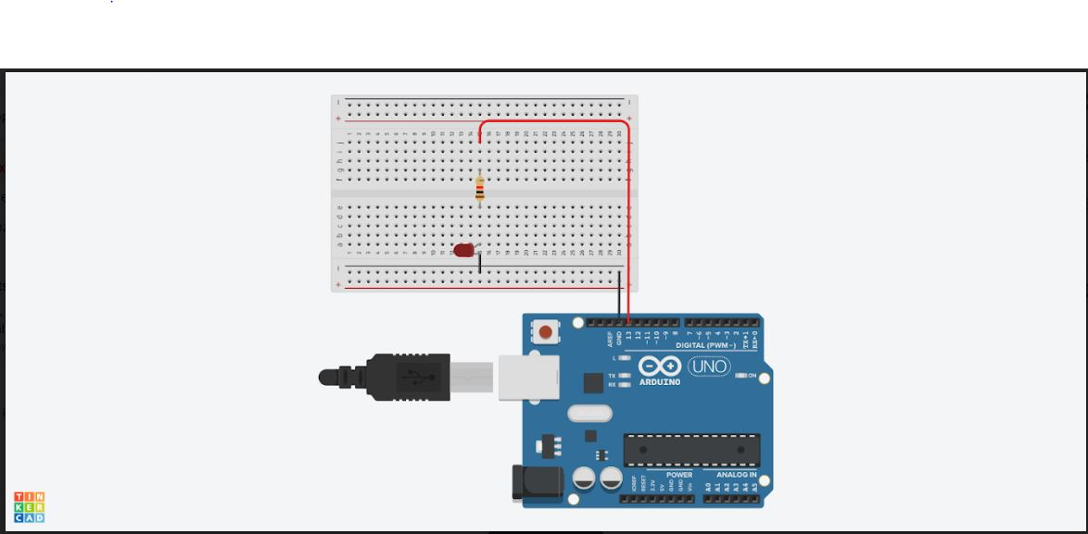

**THEORY**

**Concepts used:** 1. Ohms law

2. Circuit completion

3. Arduino ide

4. Use of breadboard

**Learning and Observations:**

1. Need of resistance

2. Led forward biasing

3. Appropriate value of resistance

4. Error free adruino code

5. proper connection of wires

**Precautions:**

While installing LED in bread board we should take care whether the terminals of LED connected or not. The two terminals should not be connected. Wires should be properly installed. Make sure resistance is connected. Arduino isn’t corrupt.

**Learning Outcomes:**

LED is flashing with the help of Arduino. No battery is connected to the circuit because Arduino provides sufficient energy for the LED to flash